ASR 3013 - EpsonGPC - SAP Open DN Matching
Release Date: 30 Jun 2010
Description: Semi-automate Daily SAP DNs matching against WMS system.
BEEF Application
Go to Admin Util -> 14. Daily Open DN Matching
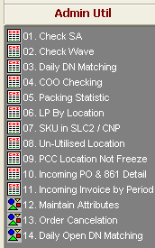
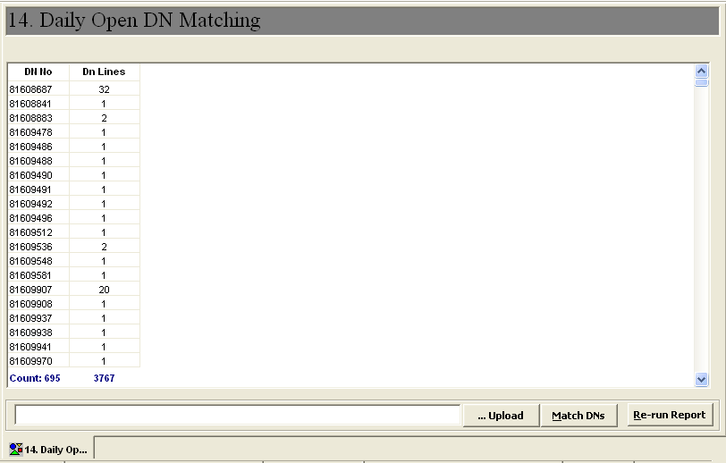

Steps:
- Save [DN_SP01] excel sheet file to tab-delimited .txt file to upload.
Format:
DN No DNLines
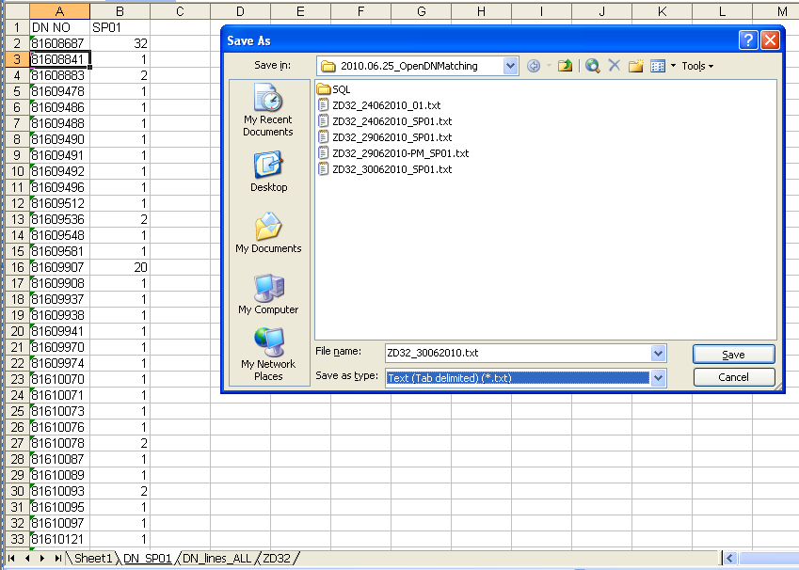

- Click button [… Upload] , browse and select the saved text file ( *.txt )
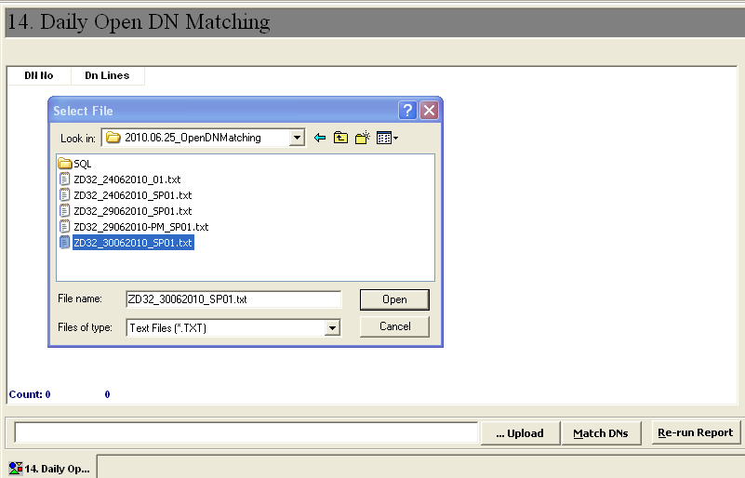
- Open DNs data will be loaded into staging window, refer screen below
- Click button [Match DNs] to process DN matching and retrieve the status report
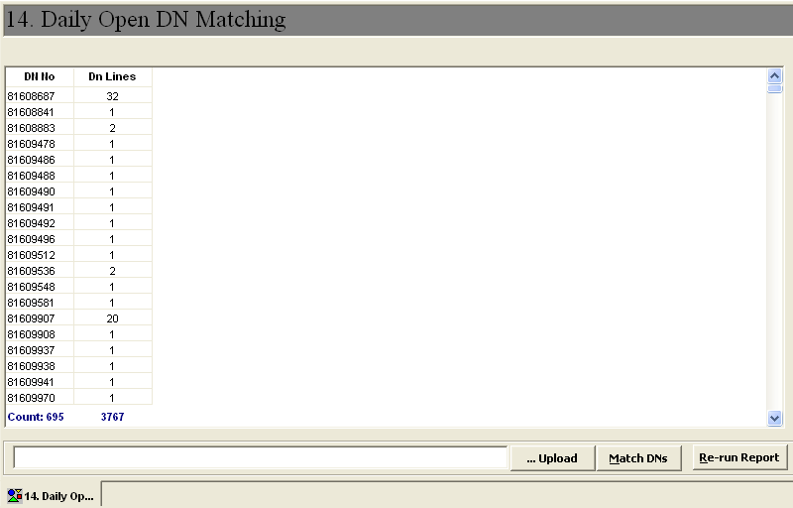

- Open DN Matching Status report as below:
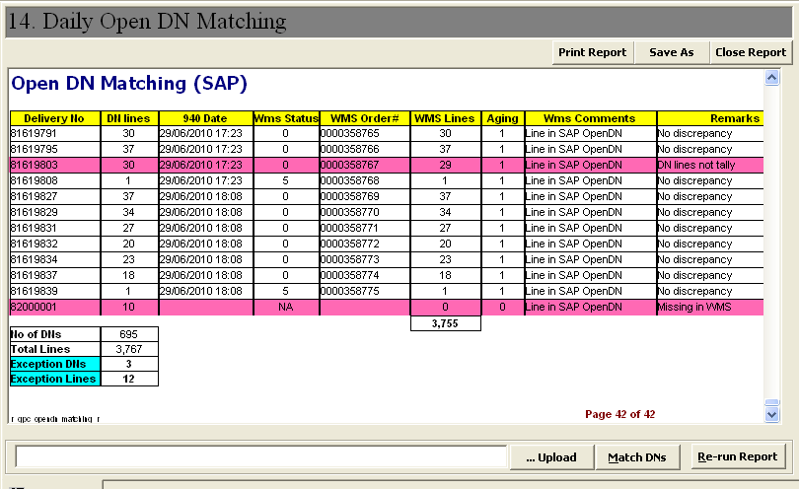
- Click button to export status report to excel format or [Save as] to save as normal excel file. Verify the detail no of DNs and Exception DNs with remarks.
- Process completed.
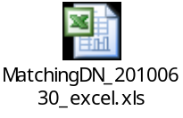
~~ End of Document ~~

